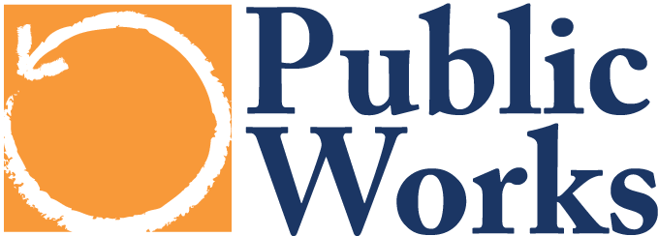
Making the Case for Public Programs & Services September 3, 2014

Exercise: Telling a New “Public Values” Story

Think of a public policy, program or service that you think gets taken for granted. How would you talk about this public system or structure using what you’ve learned so far?
a) Values
First, what is the “public good” value behind policy or program? How does is affect the quality of life in the community and/or in the province? Focus on community--not individual-- wellbeing.

b) Systems & Structures
What is the public system or structure responsible for this issue? How does it function, what role does it place in the community, in the economy?

c) Civic Responsibility
Why should we all care, how can we all support or promote this program or service? How would you talk to your neighbor about the need to support this public program or service?

Example:
Every day the health of our families and communities benefits from the work of the Newborn Screening Program at the Department of Health (Public Value).
In hospitals all across the state blood samples of newborns are sent to the health department to be screened for dozens of disorders and diseases. For any newborn identified as having one of these medical problems nurses and public health workers follow-up with families and their doctors directly to make sure they receive the treatment and care they need (Systems and Structures).
This is just one of the many reasons we should all support adequate funding for public health in our community (Civic Responsibility).

