Legislative Advocacy 101 & 201
Hosted by Neighborhood Partnerships

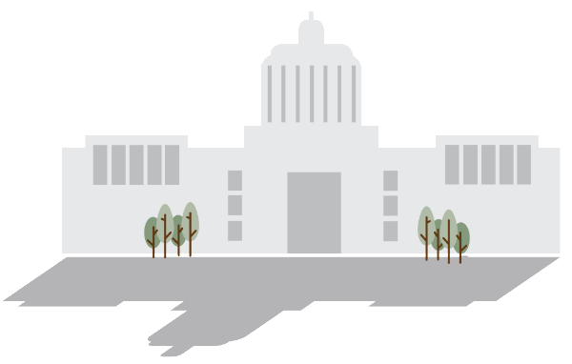

Application
Legislative Advocacy 101 – December 19, 2016 10 am to 2:30 pm
Learn the basics of advocacy. How a Bill becomes a Law, Working with Legislators, Committees and Legislative staff, Advocacy throughout session, the Legislative Calendar, Lobby Day do’s and don’ts
Legislative Advocacy 201 – January 6, 2017 10 am to 2:30 pm
More secrets of Salem. How does all this really work? How do decisions get made? How does the budget process work? What are the secrets of Ways and Means? Working with the Capitol Press Corps; Registering as a Lobbyist; and Working with Agencies

Participants will be selected based on their responses to the application questions and whether or not they are currently engaged in an advocacy campaign. We will prioritize participants based on whether they have issues in front of the upcoming Legislative session. We are also interested in helping organizations advance policy strategies particularly in the housing and asset building sectors.

Sessions will be held in Portland. They will begin at 10 am and end at 2:30 pm. The cost is $100 per session per participant. Limited scholarships are available.

To apply, please complete the following application and return it to Neighborhood Partnerships by December 1st for Legislative Advocacy 101, and by December 8th for Legislative Advocacy 201. If you have any questions, please contact Alison McIntosh (amcintosh@neighborhoodpartnerships.org, or 503-226-3001 x110.)

Contact Information

Your Name:

Organization:

Address:

Phone:

Email:

Questions

- Please describe your organization or coalition

- Experience:
Please describe your experience with legislative advocacy – For example: Have you attended lobby days in Salem? Have you attended meetings with legislators? Have you testified at a hearing? Have you coordinated grass roots advocacy?

- What is your issue focus?
We are interested in helping organizations advance policy strategies particularly in the housing and asset building sectors. What specific policy issues will your organization be working on in 2017? Please feel free to attach your policy agenda in a separate document.

- Goals:
How will improving your legislative advocacy skills help you move your issue forward? What do you most hope to learn?

- Partnerships:
One of our primary goals is to support coalition efforts in Oregon, and we hope that you will share your new skills and knowledge within your coalition. What advocacy coalitions are you an active member in, and who are your key partners in those coalitions? How will you use this training to support the work of your coalition partners? How will you share this work?

- How did you hear about the Legislative Advocacy Training?

Tuition

The tuition for the training is $100 per participant per session. Partial scholarships may be available.
If your organization cannot commit to paying $100 please fill out the section below.

- Please tell us why you need a scholarship.

- How much can your organization contribute to the cost of the training?

If written applications are a barrier for you, please contact Alison at 503.226.3001, extension 110 or amcintosh@neighborhoodpartnerships.org to discuss an accommodation.

Application Deadline:
Please email your completed application to Alison McIntosh at amcintosh@neighborhoodpartnerships.org by December 1, 2016 for Legislative Advocacy 201 or December 8th, 2016 for Legislative Advocacy 201

You can also mail or fax your application to:
Neighborhood Partnerships, Attn: Alison McIntosh
2501 SW First Avenue, Suite 120, Portland, OR 97201
Fax: 503.226.3027

