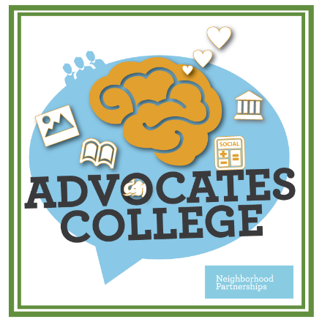

Application

Participants will be selected based on their responses to the application questions and whether or not they are currently engaged in an advocacy campaign. We will prioritize participants based on their commitment to our shared vision and to building the skills to communicate the need for good policy choices, effective public structures and adequate and reasonable revenues that will help make that vision a reality.

Sessions will be held in Portland. Dates and times are:
Day One Wednesday October 10th, 9 am to 4 pm
Day Two Wednesday November 14th
Day Three Thursday November 15th

To apply for this Advocates College, please complete the following application and return it to Neighborhood Partnerships by September 15, 2018. If you have any questions, please contact Alison (amcintosh@neighborhoodpartnerships.org, or 503-226-3001 x1010.)

Contact Information

Applicant Name:

Organization:

Address:

Phone:

Email:

Questions

- Please describe your organization or coalition

- What is your issue focus?
We are interested in helping organizations advance policy strategies using strategic communications, particularly in the housing and asset building sectors.

  - What specific policy issues will your organization be working on in 2019? Please feel free to attach your policy agenda in a separate document.

  - How will improving your messaging and communications skills help you move your issue forward? Do you have a specific communications challenge now?

- The Role of Government:
  - What role does the public sector play in addressing your policy issue? Is this primarily state, federal, or local government?

- Issue and Messaging Climate
Do you have organized opposition on your priority issue? Who are they? What potential do you see for changing the conversation on your issue?

- Partnerships:
One of our primary goals is to support coalition efforts in Oregon, and we hope that you will share your new skills and knowledge within your coalition. In addition, we believe that this training will be most valuable if you have a “team mate” or peer group who can help you incorporate new skills into your work.

  - What advocacy coalitions are you an active member in, and who are your key partners in those coalitions? How will you use this training to support the work of your coalition partners? How will you share this work?

  - Will any of your partners be applying to participate in this training? If so, who?

- Commitment to participation:
Sessions will be held in Portland. Dates and times are:
Day One Wednesday October 10th, 9 am to 4 pm
Day Two Wednesday November 14th
Day Three Thursday November 15th

- Can you commit to spend the time to prepare for and attend each session and to make time to incorporate these tools into your work?

- Why do you personally want to participate in this training? What do you hope to gain in the next two years, what do you hope to gain over the next five years, and how will you incorporate this knowledge and these skills into your work?

7. How did you hear about the Advocate’s College?

Tuition

The tuition for the training series is $1,200 per participant. Partial scholarships may be available.
If you feel that your organization cannot commit to paying $1,200 please fill out the section below.

- Please tell us why you need a scholarship.

- How much can your organization contribute to the cost of the training?

If written applications are a barrier for you, please contact Janet Byrd at 503.226.3001, extension 103 or jbyrd@neighborhoodpartnerships.org to discuss an accommodation.

Please email your completed application to Alison McIntosh at amcintosh@neighborhoodpartnerships.org by August 15, 2018

You can also mail or fax your application to:
Neighborhood Partnerships
Attn: Alison McIntosh
2501 SW First Avenue, Suite 120
Portland, OR 97201
Fax: 503.226.3027

